|  |  |
| --- | --- |
| University of Leicester logo | **MA1254 – Case Study 1** *Junbiao Li, Junhan Yang, Zihan Zhang, Zhujun Liu, Zechuan He*  *Group 8* |
|  |  |

**Consulting for colliery on quality improvement measures**

**Problem description:**

To solve the coal produced by colliery cannot reach the standard of 24 Gj/t, one direction for the company is to buy in better quality coal(sweetener) to mix with their own and the other is to use the post-processing technique. However, for different choices, the content, price and transportation cost of coal are different. We need to find the optimal choice among the six suppliers and the post-processing technique to maximize profits according to our main customer's demand.

**Analysis:**

Firstly, let's consider the method of adding sweetener to improve the calorific value of coal. There are six options for your company to choose from. Because we cannot make sure how much will the customer need, we should consider whether all the 20000 tons of coal produced a week will be processed and discussed according to the situation.

1. Mixing to 24Gj/t requires relatively less sweetener with less cost, so we firstly consider this case. If we improve the calorific value of coal to 24Gj/t, we can calculate the corresponding mixing proportion. Then, the cost and profit of per ton of the blending coal are as below. When a certain tonnage of blended coal is sold, the relevant unit price can be directly multiplied.

It is clear that the weight sold multiply the profit will be the total profit. Based on the different profit of each ton, we have the graph [1], showing the relation between total profit and weight. (Attention: in this situation no more than the maximum saleable quantity shown in the graph [1].)

[1] 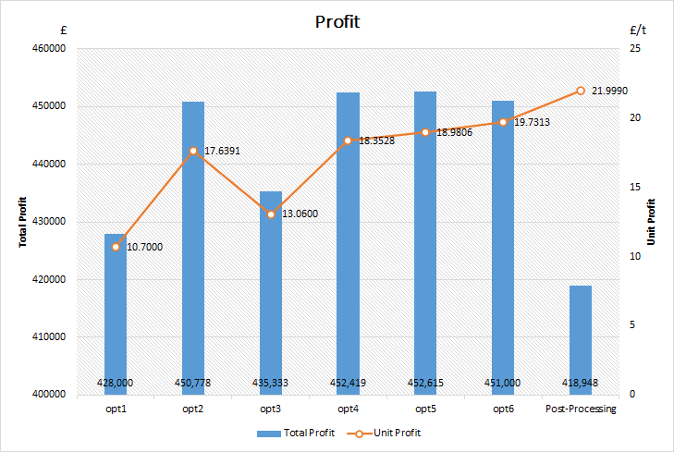[2]

1. When it comes to the post-processing technique, using the similar formulas to the situation above to calculate, we will fine the maximum finished product volume obtained is about 19044 tons, which is not much. Comparing with blending coal in graph [2], we can see it has the best profit per ton.
2. If we consider more, which means all of our 23Gj/t coal has been treated out. If the customer's demand is much more, we need to add more sweeteners. In this case, the calorific value will be higher than 24Gj/t which also satisfies our main customer’s need. But buying more and mixing more will cost more so that our total profit will the be represented on a declining curve, showing in the graph [3] below (we also put the data of post-processing in the graph).

[3]

From the graph, we can see the total profit of each option at the same weight. The point of intersection and peak are also shown clearly, which can be divided into six period with different choice. (Attention: the parts before the peak point means the own coal haven’t been all sold and the peak point and the part after the peak point represent the own coal have all used up, which help you make a trade-off decision between our main customer’s demand and maximum profit.)

**Recommendation:**

If we mainly consider the maximum profit according to the needs of our main customer:

when selling weight is **below 19044 tons**, the post-processing technique is the best choice.

In the range of **19044 to 22935 tons**, we’d better choose option6; In the range of **22935** **to 23918 tons**, we’d better choose option5; In the range of **23918 to 24766 tons,** we’d better choose option4; In the range of **24766 to 26601 tons** we’d better choose option2; In the range of **26601 to 33923 tons**, we’d better choose option3; In the range of **33923 to 44797 tons**, choosing option1 is better. And we need to have an attention that 44797 t is the maximum ton of coal we can sell, otherwise we won’t earn any money.

If we only consider selling out all our own coal: please choose option5.

**Technical formulas:**

·Mixing ratio of initial product and sweetener： *Proportion* = $\frac{1}{(CV(Gj/t)−24)}$

·The cost of buying a ton of sweetener： *Cost-buy*(£/t) = CV(Gj/t)×cost(£/Gj)+Transport(£/t)

·For each mix scheme, the total cost:

*Total cost-buy(£)* = 20000×*Proportion*×Cost-buy(£/t) + 0.5×20000×(1+*Proportion*)

·Total profit of each scheme:

*Profit(£)* = 20000 × (1 + *proportion*) × (1.2 × 24 − 2) − *Total cost-buy*(£)

·Unit profit of each mix scheme: *Unit-profit*(£/t) = 1.2×24 - 2 - 0.5 - *Proportion*×*Cost-buy*(£/t)

·Using post-processing technique, if we improve the energy content to 24Gj/t, there will be about 13651.9 t coal need to be treated. We denote this quantity as ‘m’.

·The cost of this method is: *Total cost(£)* = 6m + 0.5×(20000 - 0.07m)

·The total profit can be calculated as below:

*Net income(£)* = (20000 - 0.07m)×(1.2×24 - 2) - *Total cost(£)*

·The unit profit: *Unit-profit’(£/t) = $\frac{Net income(£)}{20000 − 0.07m}$*